**CLIMATE LAYER PROCESSING**

**Setup**

**QGIS**

* QGIS (version: 3.16)
  + MacOS: <https://qgis.org/downloads/macos/qgis-macos-ltr.dmg>
  + Windows: <https://qgis.org/downloads/QGIS-OSGeo4W-3.16.8-4.msi>
  + Other: <https://qgis.org/en/site/forusers/download.html>

**Activity #1:**

This activity was made by Rhett Rautsaw. Files for this activity can be found in *“Demo/Manual/Climate_Layer_Processing/”* folder.

**QGIS version has to be 3.16; if not, this will not work**

QGIS (version: 3.16)

1. Open QGIS.
2. Drag the layers (.tif files) found in the *“data/climate_processing/bioclim/”* folder into QGIS. They should automatically appear. The box on the left lists the different layers not the layer is displayed.
3. Add occurrence records from text-delimited file (Layer Menu > Add Layer > Add Delimited Text Layer…). Nagivate to “*data/cleaning_demo/maxent_ready/diapensiaceae_maxentready_20220625.csv*”. X field is “longitude” and Y field is “latitude”. Make sure the CRS is EPSG:4326 – WGS 84. Graphical user interface, table

   Description automatically generated
4. Create an alpha hull/shape, using the Processing Toolbox Concave Hull Tool. Set the threshold to 1. Graphical user interface, application

   Description automatically generated
5. Calculate the greatest distance using the Processing Toolbox Distance Matrix Tool. Then open the Attributes Table for that matrix and use the last column to calculate the 80th quantile to find the suggested buffer distance. Graphical user interface, application

   Description automatically generated
6. Reproject your alpha hull to a CRS in meters using the Reproject tool in the Processing Toolbox. Convert from EPSG:4326 to EPSG:3857.Graphical user interface, application

   Description automatically generated
7. Buffer your reprojected layer by the suggested buffer distance using the Buffer tool in the Processing Toolbox. Graphical user interface, text, application

   Description automatically generated
8. Next you can clip your rasters by your buffered layer using the “Clip raster by mask layer” in the Processing Toolbox. Scroll to the Clipped (mask) box and save this output to a ASCII (.asc) formatted raster.Graphical user interface, text, application, email

   Description automatically generated

Repeat for the remaining raster layers.

**Choosing layers for Ecological Niche Modeling**

The goal of this activity is to conduct a Pearson correlation in QGIS and EXCEL.

This activity was created by Maria Beatriz De Souza Cortez.

1. Vectorize clipped bioclim layers. (Creating mask)
   1. Under “Processing Toolbox” click “GDAL” and then “Polygonize (raster to vector)”.

* 1. A small window will pop open. Choose the *clipped bioclim* layer under “Input layer” and save the resulting file as .shp. Then click “Run”.

* 1. The *vectorized* layer will be displayed on top of the *clipped bioclim* layer.

1. Fix geometries of the vector (creating mask)
   1. Under “Processing Toolbox” click “Vector geometry” and then “Fix geometries”.

* 1. A small window will pop open. Choose the *vectorized* layer under “Input layer” and save the resulting file as .shp. Then click “Run”.

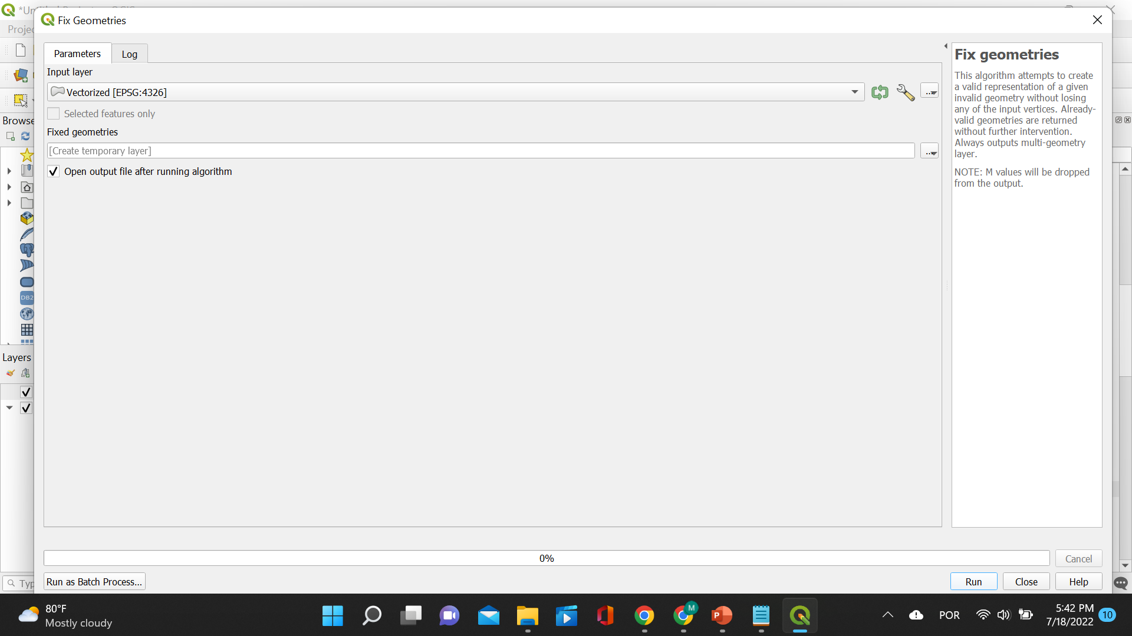

1. Dissolve the vector (creating mask)
   1. The *fixed geometry* layer will be displayed on top of the other layers. Now, click “Vector”, “Geoprocessing Tools” and then “Dissolve”

* 1. A small window will pop open. Choose the *fixed geometries* layer under “Input layer” and save the resulting file as .shp. Then click “Run”.

* 1. The *dissolved* layer will be displayed on top of the other layers. Note there are no details to this shapefile anymore, just the outline!

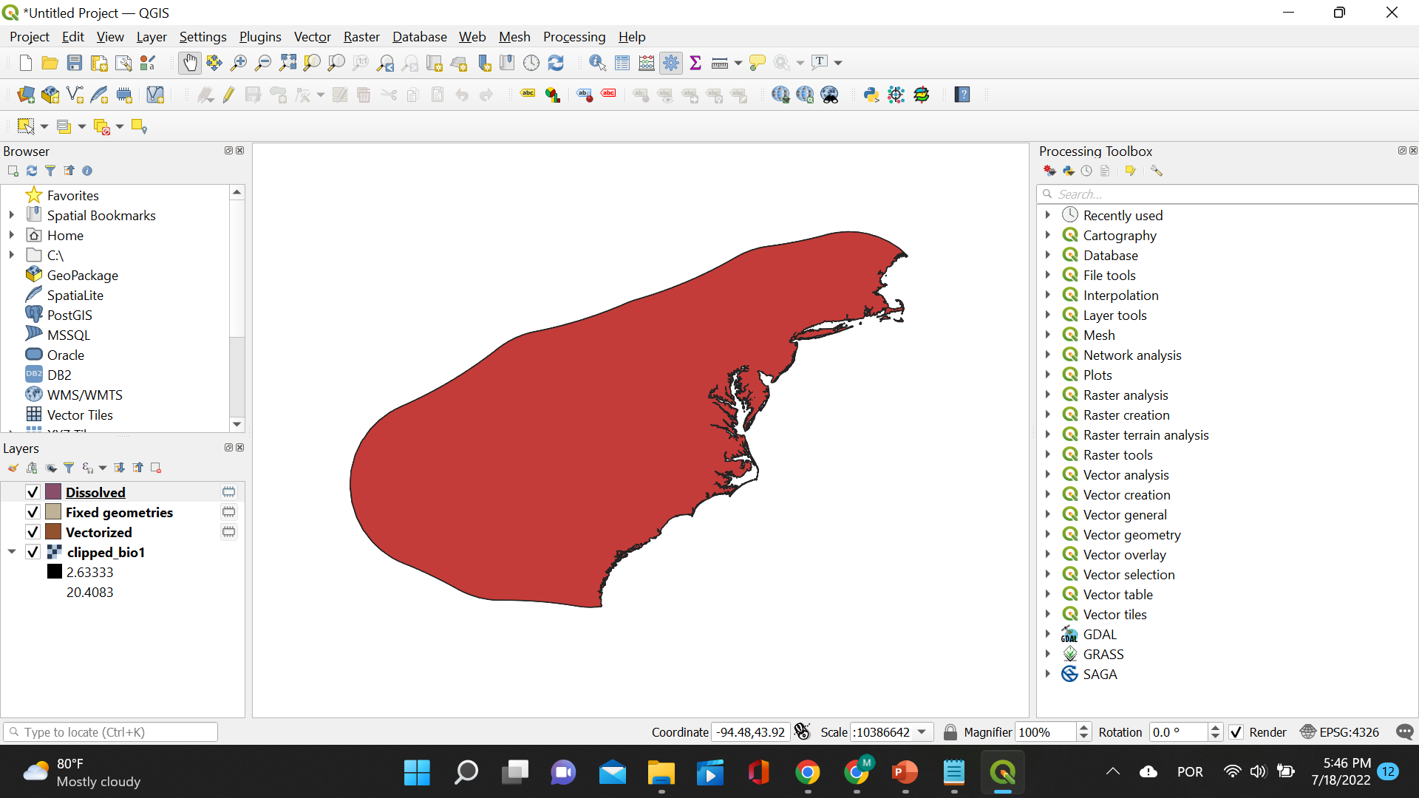

1. Create random points
   1. Click “Vector”, “Research Tools” and then “Random Points Inside Polygons”

* 1. A small window will pop open. Choose the *dissolved* layer under “Input layer”, select *Point count* for “Sampling strategy”, select *1000* for “Point count or density” and save the resulting file as .shp. Then click “Run”.

* 1. The *random points* layer will be displayed on top of the other layers

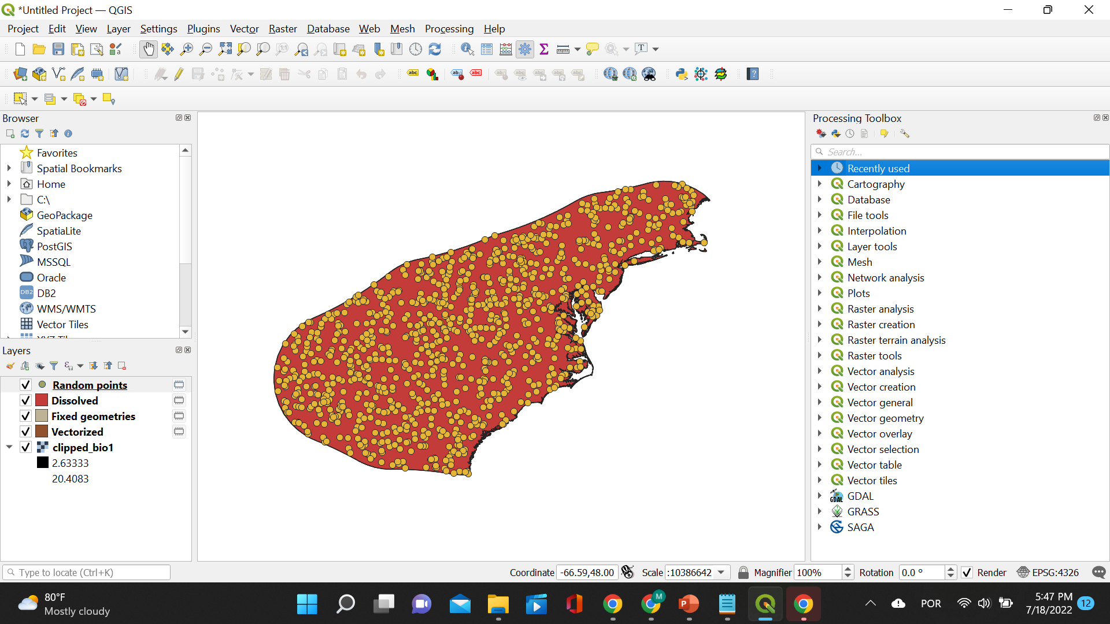

1. Sample all clipped rasters (save as .csv)
   1. Under “Processing Toolbox” click “Raster analysis” and then “Sample raster values”.

* 1. A small window will pop open. Choose the *Random points* layer under “Input layer”, select *a clipped bioclim* layer for “Raster layer” and save the resulting file as .shp. Then click “Run”.

* 1. Alternatively, you can choose to sample all the layers at once. When the window pops open you just click on “Run as Batch Process”!

* 1. Now, insert the *random points* layer under “Input layer” and all the *bioclim* layers under “Raster layer”. You are using the same sampled points for all the layers! Make sure you have all the bioclim layers loaded to QGIS. You can load all of them at once by using Autofill and selecting from the folder where they are located! The last thing you need to do is save these *sampled* *bioclim* layers as .csv files so that we can calculate correlation!

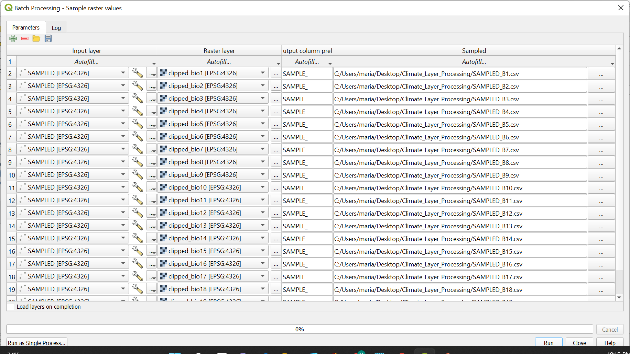

* 1. Here are the sampled *bioclim* layers!

1. Calculate correlation
   1. Now that we have a file with all the raster values for the same points for each of the bioclim layers it is time to calculate the correlation.

* 1. Under “Data” click “Data Analysis”. This is an add-in that you need to enable in your Excel! A small window will pop open, click “Correlation”

* 1. Select the cells you want to include in your calculation. Make sure to include all of the values for all of the layers.

* 1. A pairwise correlation table will appear. Let’s format it to show us the layers that are very correlated! Click “Conditional Formatting”, “Highlight Cell Rules” and “Greater Than…”. Input the number 0.7.

* 1. The values highlighted in red are all greater than 0.7. Now, it is time to eliminate at random the very correlated layers!

1. Eliminate correlated layers randomly
   1. We can start by eliminating the columns and rows from all the variables that are strongly correlated with BIO_1: 3, 5, 6, 9, 10, 11 and 14

* 1. Now we repeat the same process until we are left with no layers that are strongly correlated!